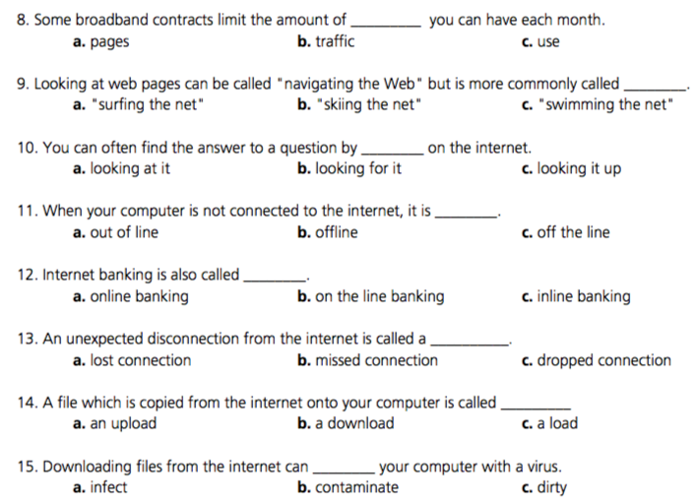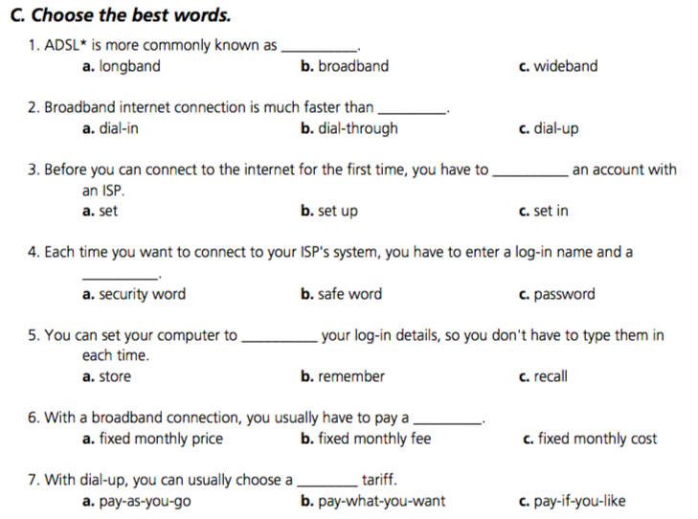

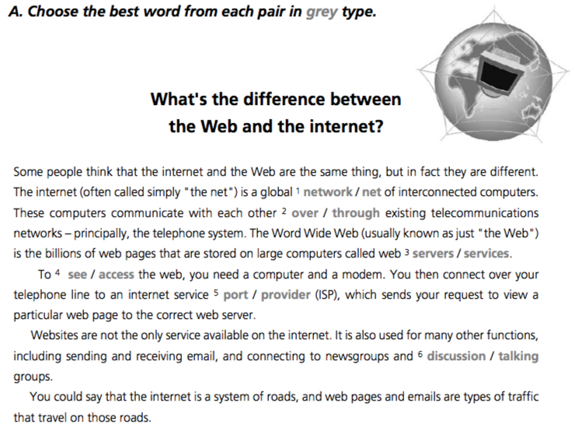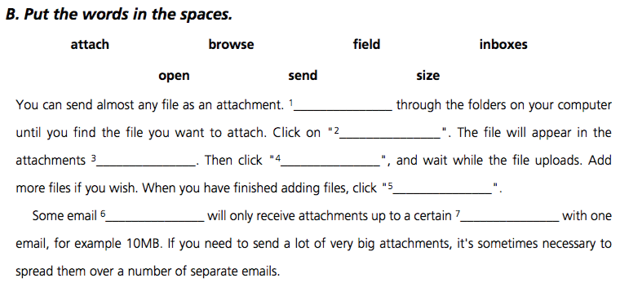

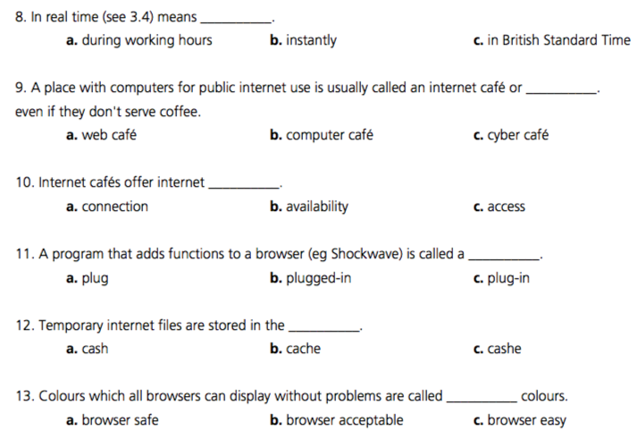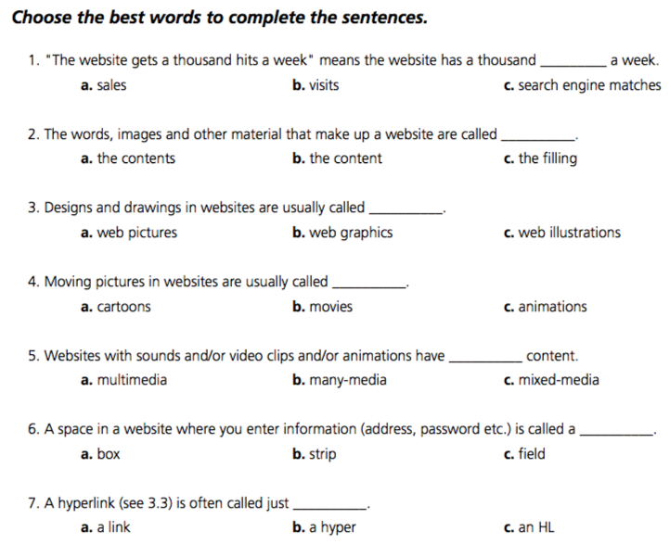

**Bài 2: Complete the sentences with words beginning with prefixes –e or -cyber**

1. A _________ is an employee who uses his company’s internet connection during work hours to chat with friends, play games, etc.
2. An ______ is a postcard sent via the Internet.
3. An ______ is a small magazine or newsletter published online.
4. In a ________ you can use computers with internet access for a fee.
5. Examples of _______ include internet fraud *(lừa đảo),* digital piracy *(vi phạm bản quyền),* theft of confidential information.
6. In the future, all elections will be carried out using ________.
7. You can now sign legal documents online using an _________.
8. __________ will revolutionize the way we take exams.
9. _______ can be used on some website instead of real money to make purchases. It reduces the risk of fraud.
10. An _______ is like the paper version, but in digital form.